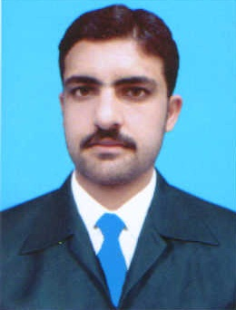***MUHAMMAD JUNAID KHAN***

**S/O**

**Muhammad Jamshed Khan**

**Present Address:**

Villag/P.O Ghani Dheri,Sakhakot

Malakand Agency

**Phone:** 0303-5997780 (Mobile)

Email: jshalmani@yahoo.com

**Marital Status:** Single  **Date of Birth:** 5th Feb 1988

**Languages:**

English & Urdu: Read, Write, Speak and Understanding Excellent

Pashto (Mother Tongue): Read, Write, Speak and Understanding Excellent

**EDUCATION**

2009-2012 **Master in Business Administration** **(MBA)**

**Sarhad University of Science & IT Peshawar, Pakistan**

**Majors in Finance and Management**

2006-2008 **Bachelor of Arts**

**Government Degree College Dargai**

**Malakand Agency**

**Abstract of Professional experience:**

Over three and half years of working experience in the sector of Administration, Project Office Management Financial Management , Book Keeping , Balance Sheet, Audit Copy and knowing of project funding.

**EMPLOYMENT**

March 2011 –April 2013 **Associate Economist Peshawar**

**Sarhad Rural Support Programme**

Under the Guideline and supervision of Project Director, I performed the following duties:

* Data Collection, Scrutiny and Critical Analysis of data, conversation of data into viable information for onwards decision making.
* Designing and preparation of planning budget pertaining to current economical scenario.
* Preparation of Trial Balance on monthly basis of all accounts of the project.
* Maintenance of accounts/ledgers etc.
* Give valuable economic inputs to the project authorities for incorporating into national level economic strategy.
* Preparation of cheque vouchers & cheques etc and recording in cash book.
* Preparation , maintained and completion of ledger Accounts

**01/03/2017 to 01/04/2019 Operation supervisor Amangarh Nowshera**

**Hascol petroleum limited**

**COMPUTER SKILLS**

Extensive experience of **Ms-Office** including Excel, Word and PowerPoint. Fully skilled in internet **based research tools**, and various **e-mail & database packages**.

**TRAININGS CONDUCTED**

* Three Days training with Pakistan Red Crescent Society(PRCS), KP

# REFERENCES

Will be furnished when desired.