MUHAMMAD ATIF SALEEM.

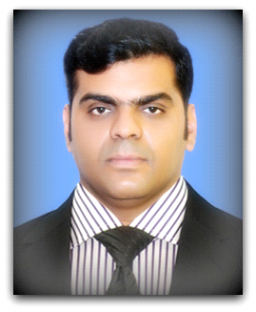

**Contact No. 03217529282**

**E-mail:**[m.a.saleem@hotmail.co.uk](mailto:m.a.saleem@hotmail.co.uk)

**H/No-275 Block J2 Wapda Town**

**Lahore.**

**Operations based professional, experienced working in a fast paced environment demanding strong organizational, technical and interpersonal skills. Trustworthy, ethical and discreet, committed to superior customer service, confident and poised in interactions with individual at all levels. Detailed oriented and resourceful in completing projects.**

* **Education and Professional Certifications**

**1997 – 1999****Metric**

Board of Intermediate And Secondary Education (PAKISTAN)

**2000 – 2002**  **I.C.S**

Scholars College.

**2000 – 2001****MCSE**

(Window 2000 Prof, Window 2000 Server, ADS, Network Infrastructure.), **MCSDBA** (SQL Server 7.0 Admin, SQL Server Design & Implementation.),

**NICON College Certified**

**2002 - 2004 ACCP**

Year 1: Semester –I (CPISM)

Year 1: Semester –II (DISM)

Year 2: (HDSE)

**Aptech Computer Education**.

* **IELTS.**

British Council

Band score 5.5

**2008-2009**

* **Advance Diploma in Information Technology**

**London Research Academy**

(Computer Networking-Hardware-System Analysis-Programming-Database Management Systems)

* **Working Skills**
* **Modular Wiring System Ltd.**

Worked 2 years as a production supervisor and maintained Computer Network. (LAN)

* **DAILY PAKISTAN NEWSPAPER**

**2004 Jan-Sep** **(Worked as web developer)**

* **Novotel London Heathrow**

**2009-2010** Worked as security supervisor and front office Assistant.

* **Vital tea Group of Companies**

**March to December 2014 Worked as Area sales Officer**

**December 2014/Feb2016 worked as a**

**Zonal Sales Manager Rwp/Isb**

* **Dawood Family Takaful Limited**

**Worked as Supervisor.**

* **Coven studios.**

**Worked as Project Supervisor.**

**Feb 2017 – Feb 2019**

* **New Life Developers.**

**Worked in recovery Department.**

**Working as sales Executive in**

**CliffSide Bhurban Residences**

**April 2019 – March 2021**

**References**

References will be furnished on request