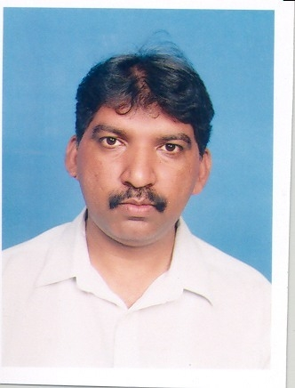
R E S U M E

Ambitious Sincere, hardworking with experience in Office Administration / Project Networking / Sales officer / Engineering Assistant & Liaison officer.

PERSONAL DETAILS:

Name : Azhar-ul-Haque
Father Name : Zafar-ul-Haque (Late)
Date of Birth : Dec, 12, 1966
Place of Birth : Rawalpindi
Nationality : Pakistani
Marital Status : Married
Permanent Address : H# 43, Street-7, New Abadi Mareer Hassan,
Rawalpindi.
Contact No. : 0300-9565175 & 051-4252780
E Mail. : azharhaq2005@yahoo.com

EDUCATIONAL BACKGROUND:

Passed Secondary School Certificate from Govt Dannay’s High School, Rawalpindi.
Passed Intermediate from Allama Iqbal Open University, Islamabad.
Qualified Bachelor of Arts from Allama Iqbal Open University, Islamabad.

PRACTICAL EXPERIENCE.

Total Oil Industry experience as more than 27 years.

- Worked as Office Administration / Engineering assistant for a period 1.6 years in Shell Pakistan Limited, Rawalpindi on Shell Contract.
- Worked as Office Administration / Engineering assistant for a period 3 years in Shell Pakistan Limited Rawalpindi through 3rd party contract M/s Design Force Consultant Rawalpindi.
- Worked as engineering assistant / Project Networking for a period 6.10 years in Shell Pakistan Limited Rawalpindi through 3rd party contract Hussain International Karachi.
- Worked as Liaison officer / CNG Coordinator for a period 6.6 years in Shell Pakistan Limited Rawalpindi through HRS Global Karachi.
- Worked as Liaison officer for a period 9.3 years since June-2012 to 30-07-2020 through 3rd party contractor.
- Worked with Total Parco Pakistan Limited as Explosives Licensing Assistant through HRSG Global Karachi from 07-04-2021 to 15-06-2021.

RESPONSIBILITIES

Network Planning

Prepare and getting all government approvals i.e. NOC; s from DC /District co-ordination officers, Explosives approvals, BPA approvals of NTI; s from concerned departments.
Estimation works for new sites.
Supervised the construction activities of running sites.
Prepare contractor documentation / tendering documents for CF new sites.
Prepare work orders for new sites i.e. CF / NDF.
Checking the contractor invoices as per site construction progress.
Checking sites layouts and submission government departments as per agreed.
Prepare and getting NHA approvals for new retail outlets as well as addition of land / CNG at existing retail outlet.
Prepare and getting BPA (Building plan Approvals) from TMA, RDA, Cant Boards for minor / new construction approvals.

CNG Approvals

Prepare cases of CNG / RLNG licenses of CF / NDF sites and submit the cases for Oil and gas Regulatory Authority Islamabad.
Prepare estimation works of CNG related jobs for NTI; s and existing sites.

Renewal of Explosives Licenses.

Prepare and submitted annual renewal cases to concerned IOE offices (Rawalpindi, Lahore, Peshawar, Muzaffarabad) and tracking of renewal process with IOE staff.

Maintenance

Maintain daily call logging (complaints from retail outlets) record
Maintain T/E sheet for maintenance jobs.
Update monthly maintenance data (Revex).
Prepare store inventory and maintain all maintenance assets.
Prepare and monitor sites maintenance / repair jobs as per requirements.
Prepare and getting Explosives amendment approvals for existing sites.
Issuance work permits for hazard area complaints.
Plan and arrange HSE training of maintenance staff as well as contract staff.
Maintain sites asset inventory as per sites record.
Maintain the complaints record and deputed the concerned maintenance staff as per agreed time period.

Administration.

- Maintain / Prepare all staff record.
- Conduct / arrange meetings in office premises.
- Maintain expenditure and store record.
- Conduct HSE e meetings as per schedule.
- Arrange / control of office transportation.
- Maintain / arrange interview process of new recruitments.

TECHNICAL QUALIFICATION:

Computer : Microsoft Word, Windows-7, XP-7
Microsoft Excel.
Microsoft Power Point.
E-Mail / Internet
Driving : Valid LTV Driving License

LANGUAGES KNOWN:

English : Good
Urdu : Good
Punjabi : Good

